Student Information System and Pearson Digital Learning Platforms Integration
Quick Start Guide for Teachers

Introduction
This guide explains how teachers sign in, access the Central Administration Tool, associate products to classes and access their Pearson digital learning platforms.

Step 1
Sign into your Schoolnet and access the online Pearson digital curriculum:
- So to Huntsville City Schools Website or Huntsvillecityschools.weebly.com
- Click on Teacher links
- Click SchoolNet (create a bookmark or shortcut)
- User name and Password are the same credentials you use to log into your computer.

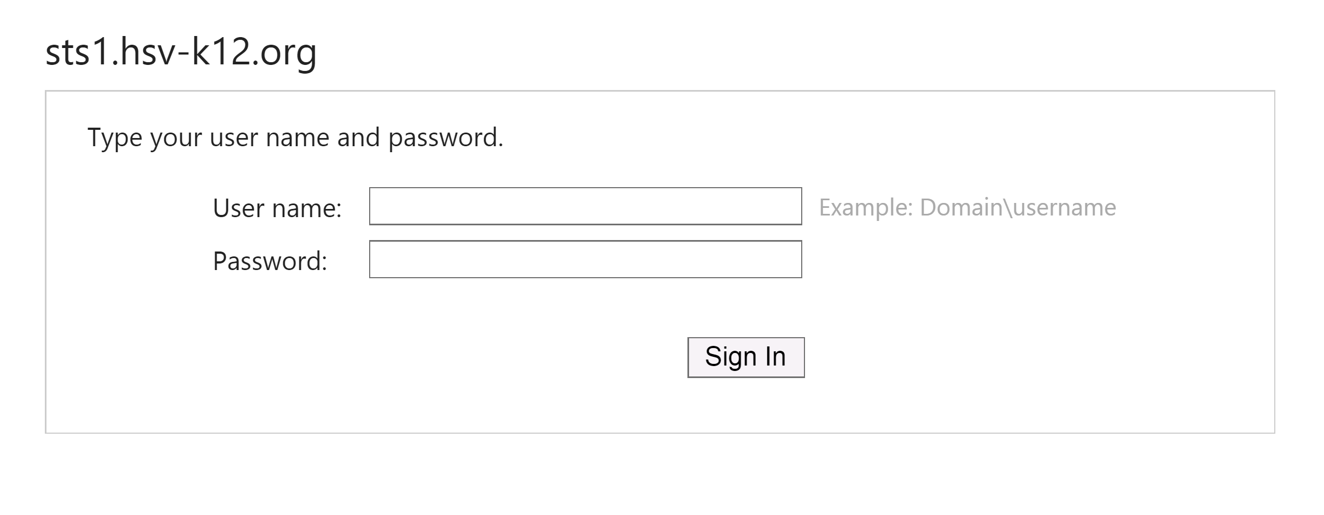

Step 2
- Click Pearson Courses.
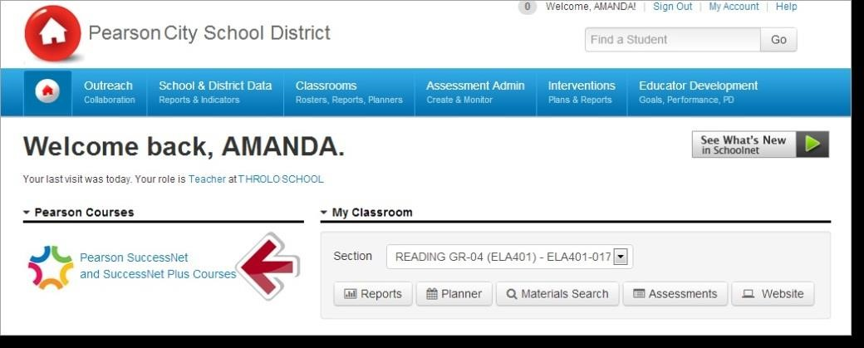

You are now on the Central Administration Tool (CAT). CAT enables teachers to associate Pearson digital curriculum products with each class.
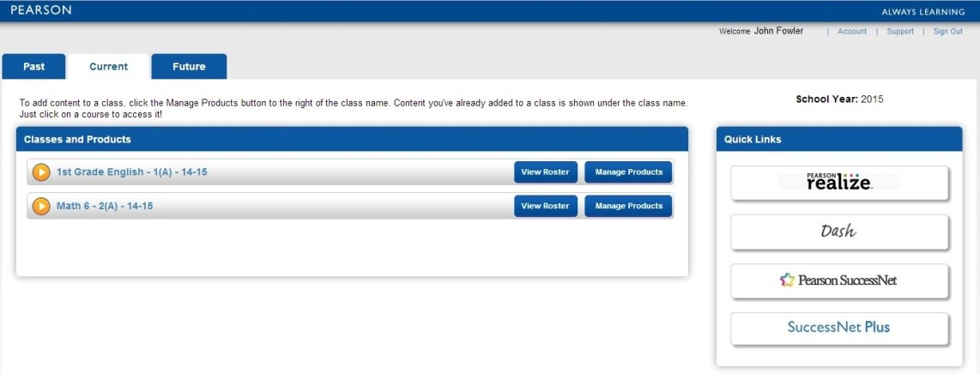

Step 3
Digital curriculum products are associated with classes at the beginning of the school year or term. To associate a product with a class, click Manage Products to the right of the class name. Select the curriculum product(s) that will be used with the class and click Save.
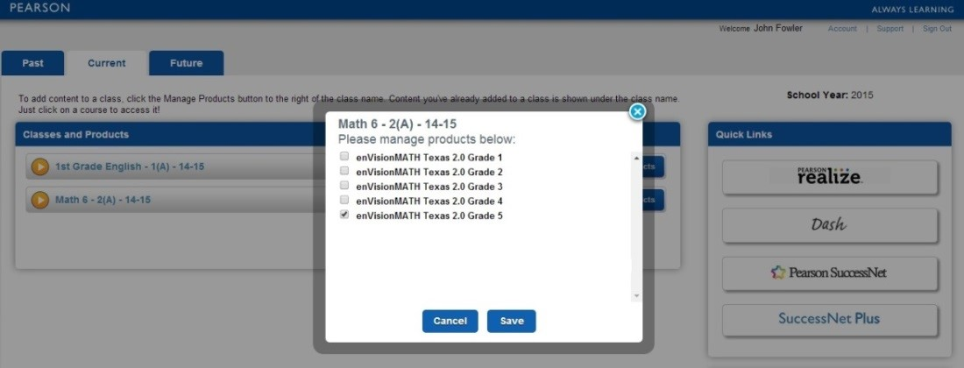

Step 4
To verify the association between the class and digital curriculum product, click the down arrow in the gold circle next to the class name.
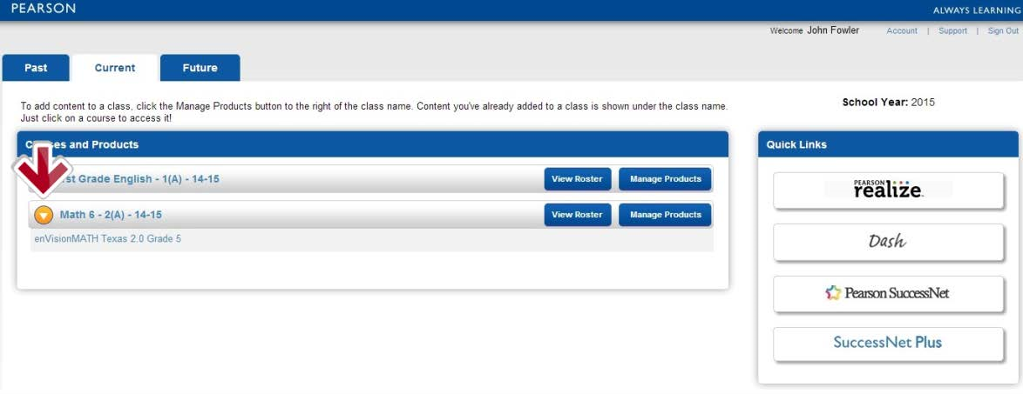

Step 5:
To access curriculum products associated with a class, do one of the following: Click the product title under the class name or click the platform name under Quick Links) Note: Teachers and students see Quick Links for the platforms used by their school or district.
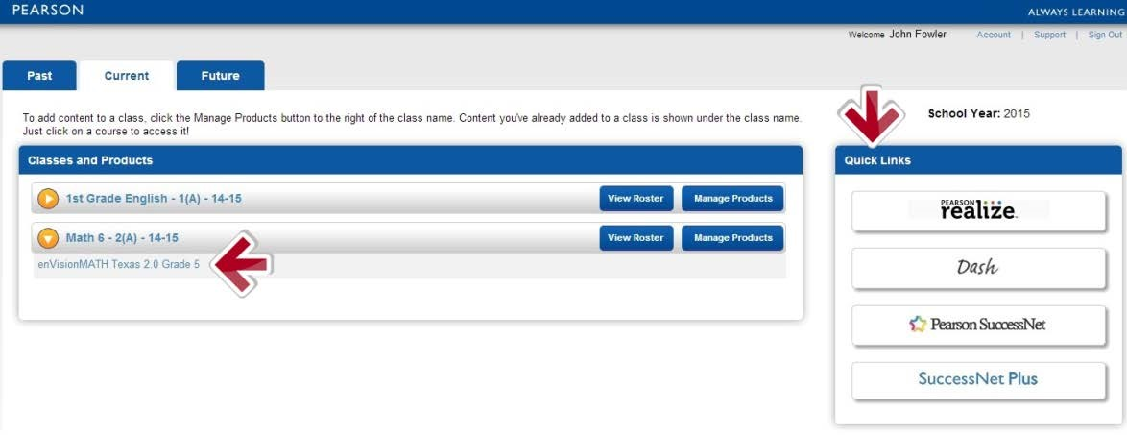

Step 6
Access the digital curriculum on the learning platform. Display content for front-of-class instruction, assign content, access teacher resources and view student progress data.
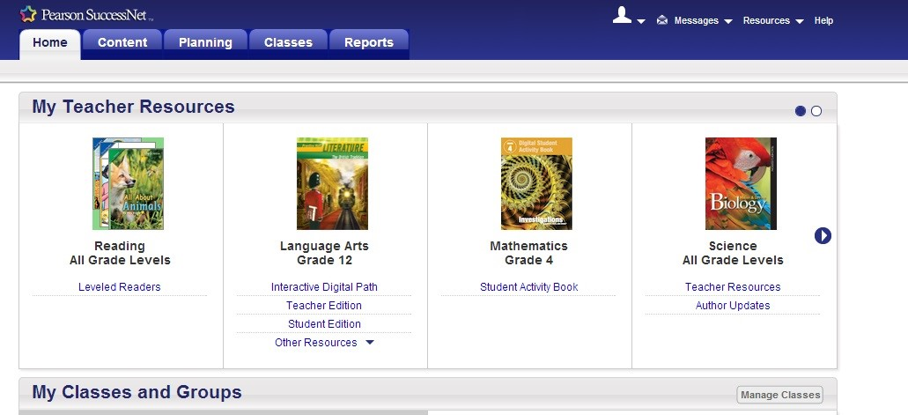

Additional Resources

To learn more about tasks completed on each digital learning platform and how to use Pearson digital curriculum, go to myPearsonTraining.com.

