Pearson Digital Learning Platforms Integration
Quick Start Guide for Teachers

Introduction
This guide explains how teachers sign in, access their Pearson Courses, associate products to classes and access their Pearson digital learning platforms.

Step 1
Sign into SchoolNet and access the online Pearson digital curriculum:

- Click on Classlinks on your desktop (look like a Chrome rainbow wheel).
- Once in Classlinks, click on the tile that says SchoolNet.
- User name and Password are the same credentials you use to log into your computer.

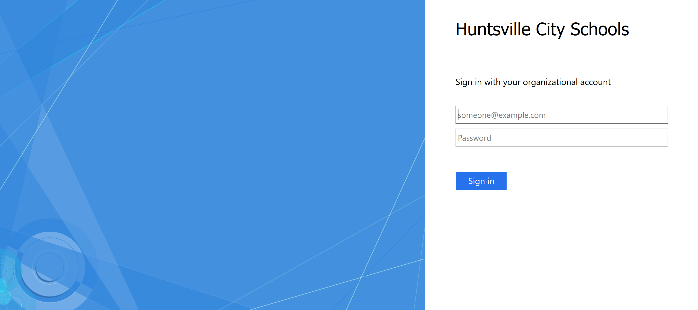

Step 2
- Click Pearson Courses.
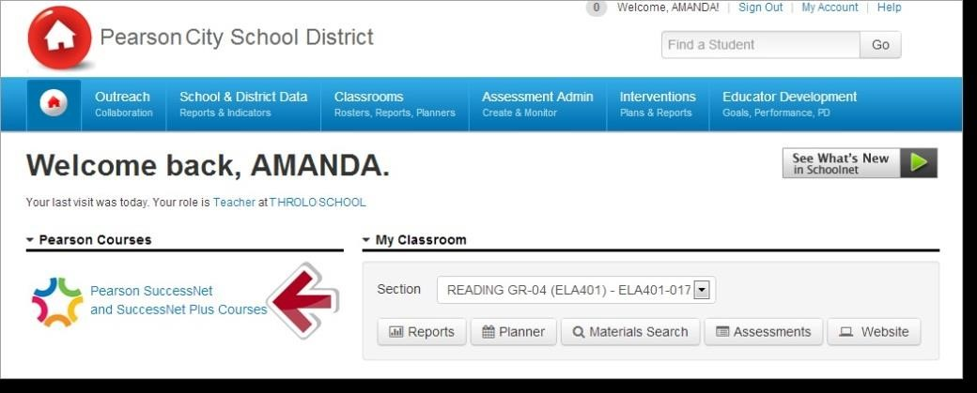

You are now on the Pearson EasyBridge Page. This enables teachers to associate Pearson digital curriculum products with each class.

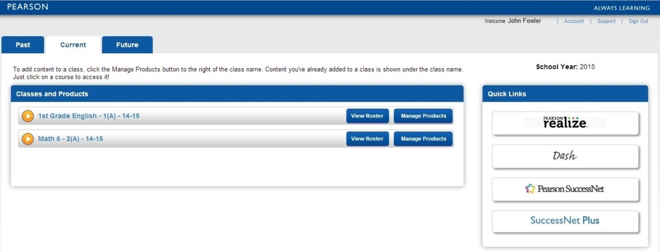

Step 3
Digital curriculum products are associated with classes at the beginning of the school year or term. To associate a product with a class, click Add Products to the right of the class section name. Select the curriculum product(s) that will be used with the class and click Save. Add the classes licensed for your grade level.
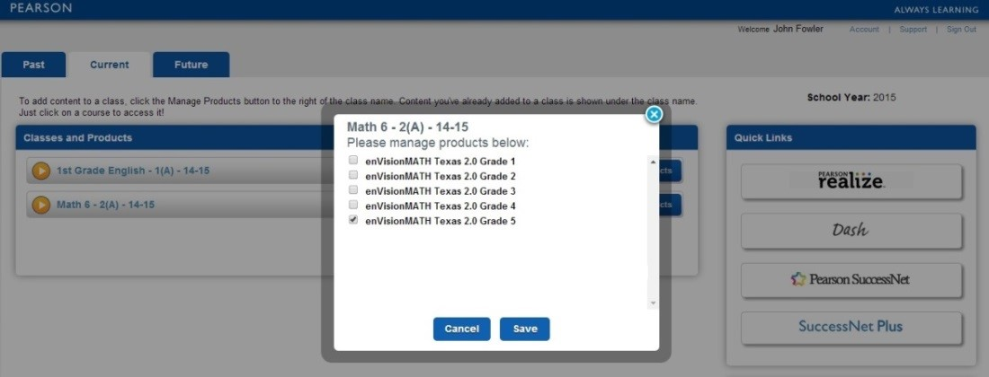

Step 4
To verify the association between the class and digital curriculum product, click on the platform under the label “Learning Systems” on the right or the drop down next to the left of the section name.

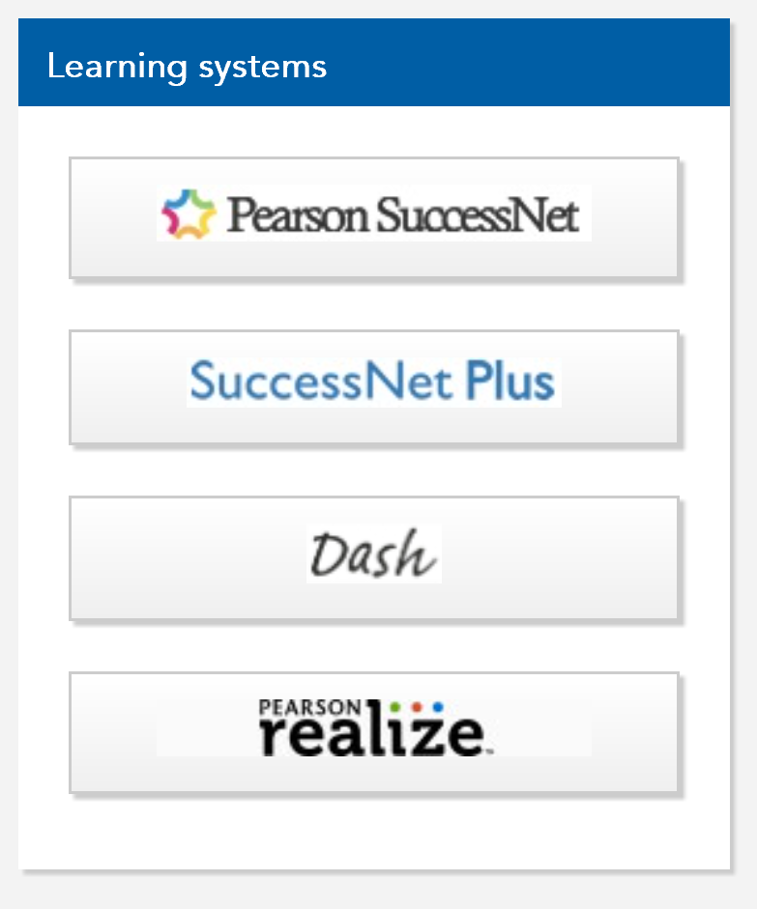

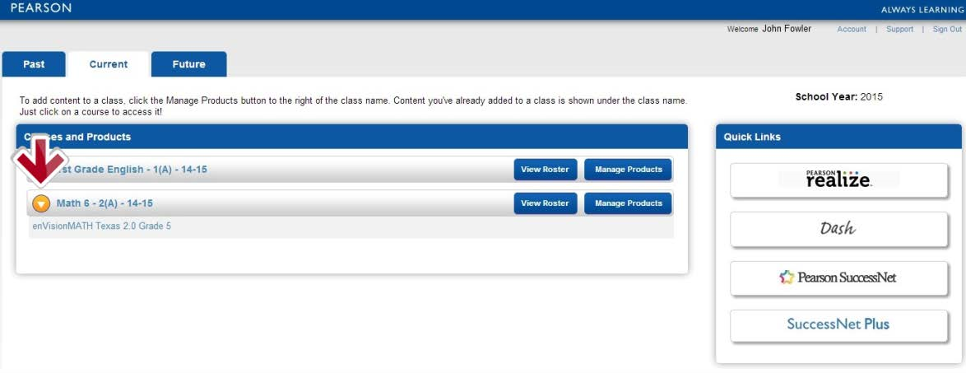

Step 5:
To access curriculum products associated with a class, do one of the following: Click the product title under the class name or click the platform name under Quick Links).
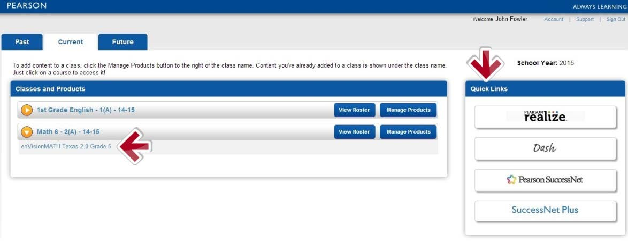

Step 6
Access the digital curriculum on the learning platform. Display content for front-of-class instruction, assign content, access teacher resources and view student progress data.
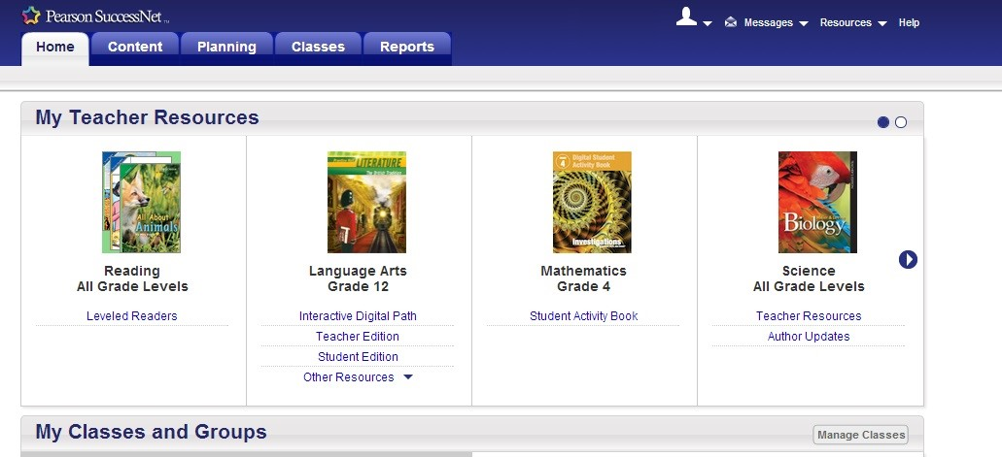

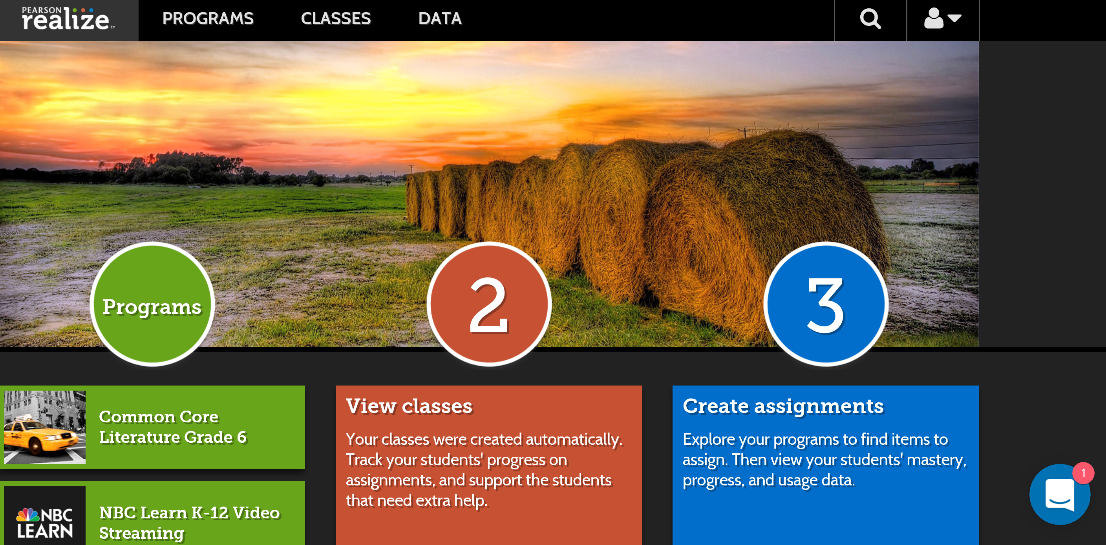

Additional Resources

To learn more about tasks completed on each digital learning platform and how to use Pearson digital curriculum, go to myPearsonTraining.com.

